Q1.

Q2.

Q3.

Q4.

Q5.

Q6.

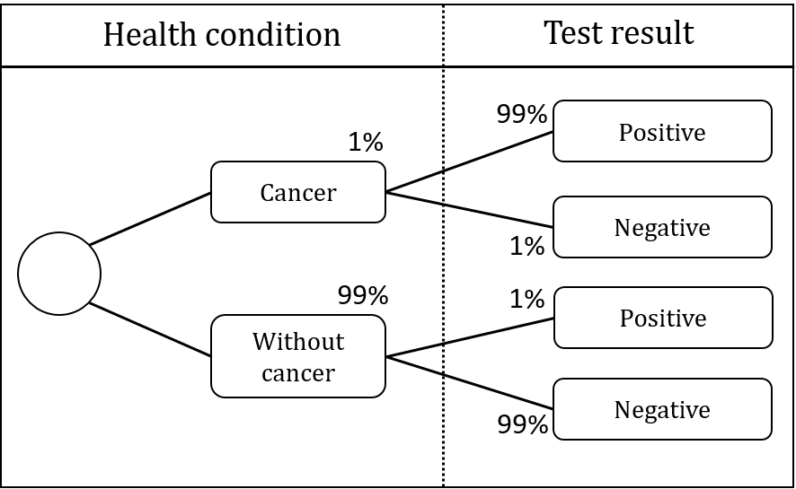

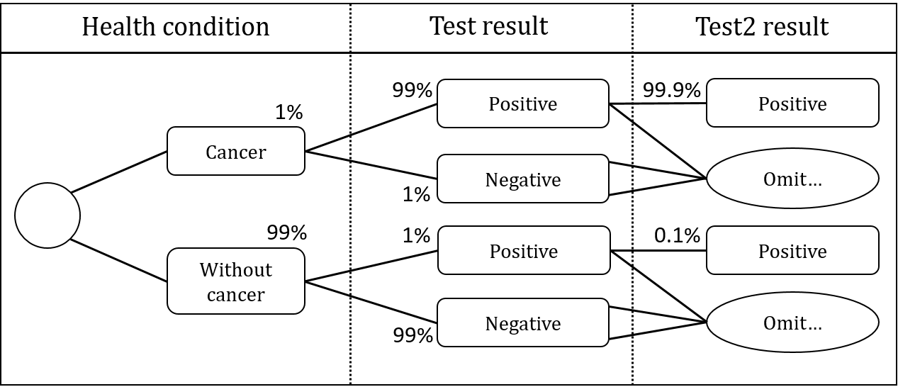

Q7.

Q8.

Q9.

|  |  |  |  |  |
| --- | --- | --- | --- | --- |
|  |  |  |  |  |
|  |  |  |  |  |
|  |  |  |  |  |
|  |  |  |  |  |
|  |  |  |  |  |

Q10.

|  |  |  |  |  |  |  |  |  |
| --- | --- | --- | --- | --- | --- | --- | --- | --- |
|  |  |  | |  | |  | |  |
|  |  |
|  | |  |  |  |  |  |  |  |
|  |  |  |  |  |  |
|  | |  |  |  |  |  |  |  |
|  |  |  |  |  |  |
|  | |  |  |  |  |  |  |  |
|  |  |  |  |  |  |
|  | |  | |  | |  | |  |